NAME: VIGNESHWAR.D
REG.NO: 192524415
COURSE: CSA1515-Cloud Computing

EXPERIMENT 10
MARK SHEET PROCESSING SYSTEM (SAAS)

AIM:
To create a simple cloud based Student Mark Processing Application Using Zoho Creator , a Saas Platform.

IMAGES:
Dashboard:
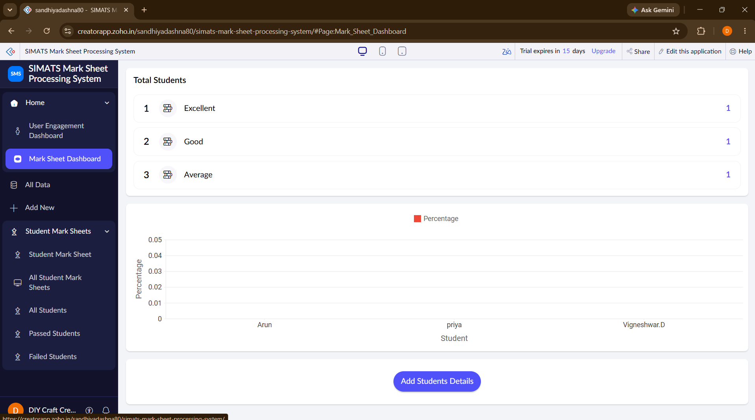

FORM:
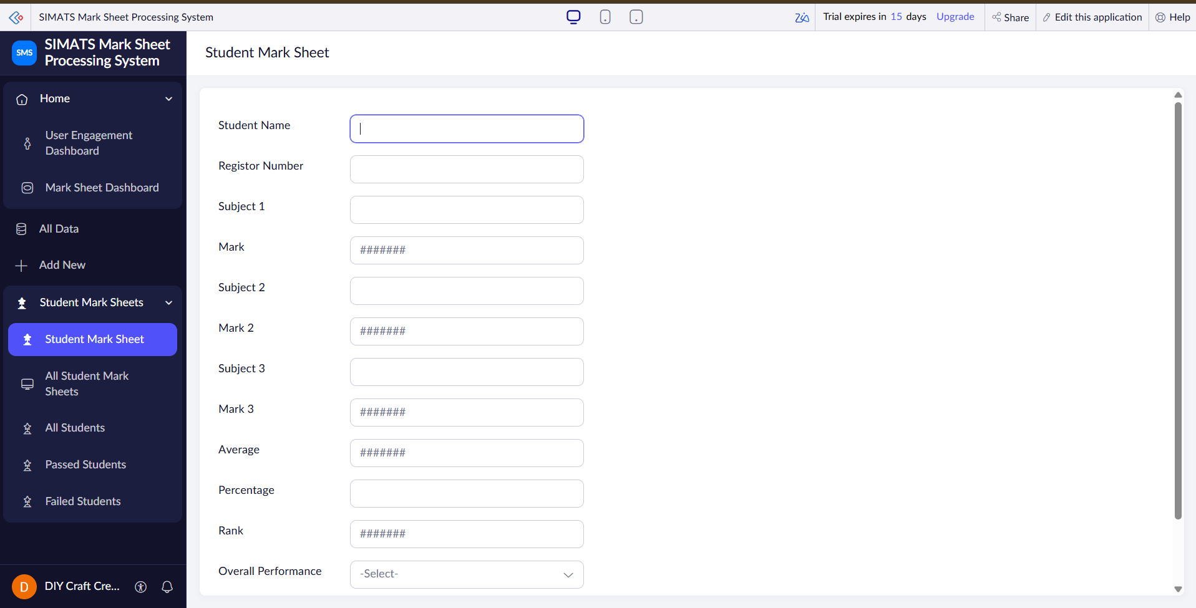

REPORT: 

